Case Study: 5
Title: To study and implement arrays, array manipulation functions, array methods, and loops in JavaScript using HTML, CSS, and JavaScript, including push(), pop(), shift(), unshift(), splice(), slice(), map(), filter(), reduce(), forEach(), and different types of loops.
Software/Tools Required: VSC, HTML, CSS, JavaScript
Case Study program code:
index.html:
<!DOCTYPE html>
<html lang="en">
<head>
<meta charset="UTF-8">
<meta name="viewport" content="width=device-width, initial-scale=1.0">
<title>JavaScript Arrays & Loops</title>
<link rel="stylesheet" href="style.css">
</head>
<body>
<header class="hero">
<div class="badge">JavaScript Practical</div>
<h1>Arrays & Loops in JavaScript</h1>
<p>Explore array manipulation, array methods, loops, and the maximum/minimum case study.</p>
</header>

<main class="container">
<section class="card">
<div class="section-heading">
<div>
<span class="eyebrow">Case Study</span>
<h2>Find Maximum & Minimum</h2>
</div>
<span class="array-tag">[25, 10, 45, 5, 30, 15]</span>
</div>

<div class="case-grid">
<div class="array-box">
<h3>Array</h3>
<div id="caseArray" class="array-display"></div>
<button id="caseStudyBtn" class="primary-btn">Find Max & Min</button>
</div>
<div class="result-box">
<div class="result-item">
<span>Maximum Value</span>
<strong id="maxValue">—</strong>
</div>
<div class="result-item">
<span>Minimum Value</span>
<strong id="minValue">—</strong>
</div>
</div>
</div>
</section>

<section class="card">
<div class="section-heading">
<div>
<span class="eyebrow">Task A</span>
<h2>Create & Manipulate Arrays</h2>
<p>Try push(), pop(), shift(), unshift(), splice(), and slice().</p>
</div>
</div>

<div class="array-workspace">
<div class="current-array">
<h3>Current Array</h3>
<div id="currentArray" class="array-display"></div>
<button id="resetBtn" class="secondary-btn">Reset Array</button>
</div>

<div class="controls">
<div class="control-group">
<label for="valueInput">Value</label>
<input id="valueInput" type="text" placeholder="e.g. 50">
</div>

<div class="button-grid">
<button data-action="push">push()</button>
<button data-action="pop">pop()</button>
<button data-action="shift">shift()</button>
<button data-action="unshift">unshift()</button>
<button data-action="splice">splice()</button>
<button data-action="slice">slice()</button>
</div>
</div>
</div>

<div id="operationOutput" class="output">
Select an operation to see the result.
</div>
</section>

<section class="card">
<div class="section-heading">
<div>
<span class="eyebrow">Task B</span>
<h2>Array Methods</h2>
<p>Use map(), filter(), reduce(), and forEach() on the current array.</p>
</div>
</div>

<div class="method-grid">
<button data-method="map">map() — Double Values</button>
<button data-method="filter">filter() — Values &gt; 20</button>
<button data-method="reduce">reduce() — Sum</button>
<button data-method="forEach">forEach() — Display Values</button>
</div>

<div id="methodOutput" class="output">
Select an array method to see the result.
</div>
</section>

<section class="card">
<div class="section-heading">
<div>
<span class="eyebrow">Loops</span>
<h2>Loops in JavaScript</h2>
<p>Run the same array through for, while, and do...while loops.</p>
</div>
</div>

<div class="loop-grid">
<button data-loop="for">for loop</button>
<button data-loop="while">while loop</button>
<button data-loop="doWhile">do...while loop</button>
</div>

<div id="loopOutput" class="output">
Select a loop to see its output.
</div>
</section>

<section class="card reference-card">
<span class="eyebrow">Quick Reference</span>
<h2>Functions Included</h2>
<div class="reference-grid">
<div><code>push()</code><span>Adds at the end</span></div>
<div><code>pop()</code><span>Removes from the end</span></div>
<div><code>shift()</code><span>Removes from the beginning</span></div>
<div><code>unshift()</code><span>Adds at the beginning</span></div>
<div><code>splice()</code><span>Adds/removes at an index</span></div>
<div><code>slice()</code><span>Copies a selected portion</span></div>
<div><code>map()</code><span>Transforms each value</span></div>
<div><code>filter()</code><span>Selects matching values</span></div>
<div><code>reduce()</code><span>Combines values into one result</span></div>
<div><code>forEach()</code><span>Runs a function for every value</span></div>
</div>
</section>
</main>

<footer>
JavaScript Arrays & Loops Practical
</footer>

<script src="script.js"></script>
</body>
</html>

Script.js:
const originalArray = [25, 10, 45, 5, 30, 15];
let numbers = [...originalArray];

const currentArrayEl = document.getElementById("currentArray");
const operationOutput = document.getElementById("operationOutput");
const methodOutput = document.getElementById("methodOutput");
const loopOutput = document.getElementById("loopOutput");
const valueInput = document.getElementById("valueInput");

function renderArray(element, arr) {
element.innerHTML = "";

if (arr.length === 0) {
element.innerHTML = "<span>Array is empty</span>";
return;
}

arr.forEach(value => {
const item = document.createElement("span");
item.className = "array-item";
item.textContent = value;
element.appendChild(item);
});
}

function getValue() {
const value = valueInput.value.trim();

if (value === "") {
return 50;
}

const number = Number(value);
return Number.isNaN(number) ? value : number;
}

function updateCurrentArray() {
renderArray(currentArrayEl, numbers);
}

// Task A: push()
function pushElement() {
const value = getValue();
numbers.push(value);
operationOutput.textContent =
`push(${value}) → element added to the end.\nNew Array: [${numbers.join(", ")}]`;
updateCurrentArray();
}

// Task A: pop()
function popElement() {
const removed = numbers.pop();
operationOutput.textContent =
`pop() → removed: ${removed ?? "undefined"}\nNew Array: [${numbers.join(", ")}]`;
updateCurrentArray();
}

// Task A: shift()
function shiftElement() {
const removed = numbers.shift();
operationOutput.textContent =
`shift() → removed: ${removed ?? "undefined"}\nNew Array: [${numbers.join(", ")}]`;
updateCurrentArray();
}

// Task A: unshift()
function unshiftElement() {
const value = getValue();
numbers.unshift(value);
operationOutput.textContent =
`unshift(${value}) → element added to the beginning.\nNew Array: [${numbers.join(", ")}]`;
updateCurrentArray();
}

// Task A: splice()
function spliceElement() {
if (numbers.length === 0) {
operationOutput.textContent = "splice() → array is empty.";
return;
}

const index = Math.min(2, numbers.length - 1);
const removed = numbers.splice(index, 1, getValue());

operationOutput.textContent =
`splice(${index}, 1, value) → replaced the element at index ${index}.\n` +
`Removed: ${removed.join(", ")}\nNew Array: [${numbers.join(", ")}]`;

updateCurrentArray();
}

// Task A: slice()
function sliceArray() {
const start = 1;
const end = Math.min(4, numbers.length);
const result = numbers.slice(start, end);

operationOutput.textContent =
`slice(${start}, ${end}) → creates a copy from index ${start} to ${end - 1}.\n` +
`Result: [${result.join(", ")}]\nOriginal Array remains: [${numbers.join(", ")}]`;
}

// Task B: map()
function mapArray() {
const result = numbers.map(number => {
return typeof number === "number" ? number * 2 : number;
});

methodOutput.textContent =
`map() → doubles every numeric value.\nResult: [${result.join(", ")}]`;
}

// Task B: filter()
function filterArray() {
const result = numbers.filter(number => {
return typeof number === "number" && number > 20;
});

methodOutput.textContent =
`filter() → keeps numeric values greater than 20.\nResult: [${result.join(", ")}]`;
}

// Task B: reduce()
function reduceArray() {
const result = numbers.reduce((sum, number) => {
return typeof number === "number" ? sum + number : sum;
}, 0);

methodOutput.textContent =
`reduce() → adds all numeric values.\nSum: ${result}`;
}

// Task B: forEach()
function forEachArray() {
let output = "";

numbers.forEach((value, index) => {
output += `Index ${index}: ${value}\n`;
});

methodOutput.textContent =
`forEach() → visits every array element.\n${output || "Array is empty."}`;
}

// Case study: maximum and minimum
function findMaxMin() {
if (originalArray.length === 0) {
return;
}

const maximum = Math.max(...originalArray);
const minimum = Math.min(...originalArray);

document.getElementById("maxValue").textContent = maximum;
document.getElementById("minValue").textContent = minimum;
}

// for loop
function runForLoop() {
let output = "";

for (let i = 0; i < numbers.length; i++) {
output += numbers[i] + (i < numbers.length - 1 ? " → " : "");
}

loopOutput.textContent = `for loop:\n${output || "Array is empty."}`;
}

// while loop
function runWhileLoop() {
let i = 0;
let output = [];

while (i < numbers.length) {
output.push(numbers[i]);
i++;
}

loopOutput.textContent =
`while loop:\n${output.length ? output.join(" → ") : "Array is empty."}`;
}

// do...while loop
function runDoWhileLoop() {
let i = 0;
let output = [];

if (numbers.length > 0) {
do {
output.push(numbers[i]);
i++;
} while (i < numbers.length);
}

loopOutput.textContent =
`do...while loop:\n${output.length ? output.join(" → ") : "Array is empty."}`;
}

// Manipulation buttons
document.querySelectorAll("[data-action]").forEach(button => {
button.addEventListener("click", () => {
const action = button.dataset.action;

const actions = {
push: pushElement,
pop: popElement,
shift: shiftElement,
unshift: unshiftElement,
splice: spliceElement,
slice: sliceArray
};

actions[action]();
});
});

// Array method buttons
document.querySelectorAll("[data-method]").forEach(button => {
button.addEventListener("click", () => {
const methods = {
map: mapArray,
filter: filterArray,
reduce: reduceArray,
forEach: forEachArray
};

methods[button.dataset.method]();
});
});

// Loop buttons
document.querySelectorAll("[data-loop]").forEach(button => {
button.addEventListener("click", () => {
const loops = {
for: runForLoop,
while: runWhileLoop,
doWhile: runDoWhileLoop
};

loops[button.dataset.loop]();
});
});

document.getElementById("caseStudyBtn").addEventListener("click", findMaxMin);

document.getElementById("resetBtn").addEventListener("click", () => {
numbers = [...originalArray];
updateCurrentArray();
operationOutput.textContent = "Array reset to [25, 10, 45, 5, 30, 15].";
methodOutput.textContent = "Select an array method to see the result.";
loopOutput.textContent = "Select a loop to see its output.";
});

valueInput.addEventListener("keydown", event => {
if (event.key === "Enter") {
pushElement();
}
});

// Initial display
renderArray(document.getElementById("caseArray"), originalArray);
updateCurrentArray();

Style.css:
* {
box-sizing: border-box;
margin: 0;
padding: 0;
}

body {
font-family: "Segoe UI", Arial, sans-serif;
background: #f4f7fb;
color: #172033;
line-height: 1.5;
}

.hero {
background: linear-gradient(135deg, #16213e, #283b73);
color: white;
padding: 54px 20px;
text-align: center;
}

.badge,
.eyebrow {
display: inline-block;
font-size: 12px;
font-weight: 800;
letter-spacing: 1.5px;
text-transform: uppercase;
}

.badge {
padding: 7px 12px;
border: 1px solid rgba(255,255,255,.35);
border-radius: 999px;
margin-bottom: 15px;
}

.hero h1 {
font-size: clamp(30px, 5vw, 48px);
margin-bottom: 10px;
}

.hero p {
color: #dbe4ff;
max-width: 700px;
margin: auto;
}

.container {
width: min(1050px, 92%);
margin: 32px auto 50px;
display: grid;
gap: 24px;
}

.card {
background: white;
border: 1px solid #e2e7f0;
border-radius: 18px;
padding: 28px;
box-shadow: 0 10px 30px rgba(30, 48, 85, .07);
}

.section-heading {
display: flex;
justify-content: space-between;
gap: 20px;
align-items: flex-start;
margin-bottom: 24px;
}

.eyebrow {
color: #5267bd;
margin-bottom: 5px;
}

h2 {
font-size: 25px;
margin-bottom: 5px;
}

h3 {
font-size: 17px;
margin-bottom: 12px;
}

.section-heading p {
color: #68738a;
}

.array-tag {
background: #eef1ff;
color: #4053a2;
padding: 9px 13px;
border-radius: 10px;
font-family: Consolas, monospace;
white-space: nowrap;
}

.case-grid,
.array-workspace {
display: grid;
grid-template-columns: 1.25fr .75fr;
gap: 20px;
}

.array-box,
.result-box,
.current-array,
.controls {
background: #f8faff;
border: 1px solid #e3e8f3;
border-radius: 14px;
padding: 20px;
}

.array-display {
min-height: 56px;
background: #fff;
border: 1px dashed #b9c2d5;
border-radius: 10px;
padding: 12px;
display: flex;
flex-wrap: wrap;
align-items: center;
gap: 8px;
margin-bottom: 16px;
font-family: Consolas, monospace;
}

.array-item {
background: #e9edff;
color: #293b8e;
padding: 7px 10px;
border-radius: 7px;
font-weight: 700;
}

button {
border: 0;
border-radius: 10px;
padding: 12px 15px;
font-weight: 700;
cursor: pointer;
background: #e9edff;
color: #273b8c;
transition: .2s ease;
}

button:hover {
transform: translateY(-2px);
filter: brightness(.97);
}

.primary-btn {
background: #2d438f;
color: white;
}

.secondary-btn {
background: #e8ebf2;
color: #344056;
}

.result-box {
display: grid;
gap: 12px;
}

.result-item {
background: white;
border-radius: 12px;
padding: 18px;
border: 1px solid #e5e9f2;
}

.result-item span {
display: block;
color: #68738a;
font-size: 14px;
}

.result-item strong {
display: block;
font-size: 34px;
color: #2d438f;
margin-top: 4px;
}

.controls {
display: flex;
flex-direction: column;
gap: 18px;
}

.control-group label {
display: block;
font-size: 14px;
font-weight: 700;
margin-bottom: 7px;
}

input {
width: 100%;
padding: 12px 13px;
border: 1px solid #cbd3e2;
border-radius: 9px;
outline: none;
font-size: 15px;
}

input:focus {
border-color: #5267bd;
}

.button-grid,
.method-grid,
.loop-grid {
display: grid;
grid-template-columns: repeat(2, 1fr);
gap: 10px;
}

.output {
margin-top: 20px;
padding: 17px;
border-left: 4px solid #5267bd;
background: #f5f7ff;
border-radius: 8px;
font-family: Consolas, monospace;
min-height: 55px;
white-space: pre-wrap;
}

.reference-card {
background: #172033;
color: white;
}

.reference-card .eyebrow {
color: #aebcff;
}

.reference-grid {
display: grid;
grid-template-columns: repeat(2, 1fr);
gap: 10px;
margin-top: 18px;
}

.reference-grid div {
display: flex;
align-items: center;
gap: 10px;
background: rgba(255,255,255,.07);
padding: 12px;
border-radius: 9px;
}

code {
color: #cbd4ff;
font-weight: 800;
}

.reference-grid span {
color: #cbd2df;
font-size: 14px;
}

footer {
text-align: center;
padding: 25px;
color: #778196;
}

@media (max-width: 720px) {
.case-grid,
.array-workspace {
grid-template-columns: 1fr;
}

.section-heading {
flex-direction: column;
}

.array-tag {
white-space: normal;
}

.button-grid,
.method-grid,
.loop-grid,
.reference-grid {
grid-template-columns: 1fr;
}

.card {
padding: 20px;
}
}

Output:

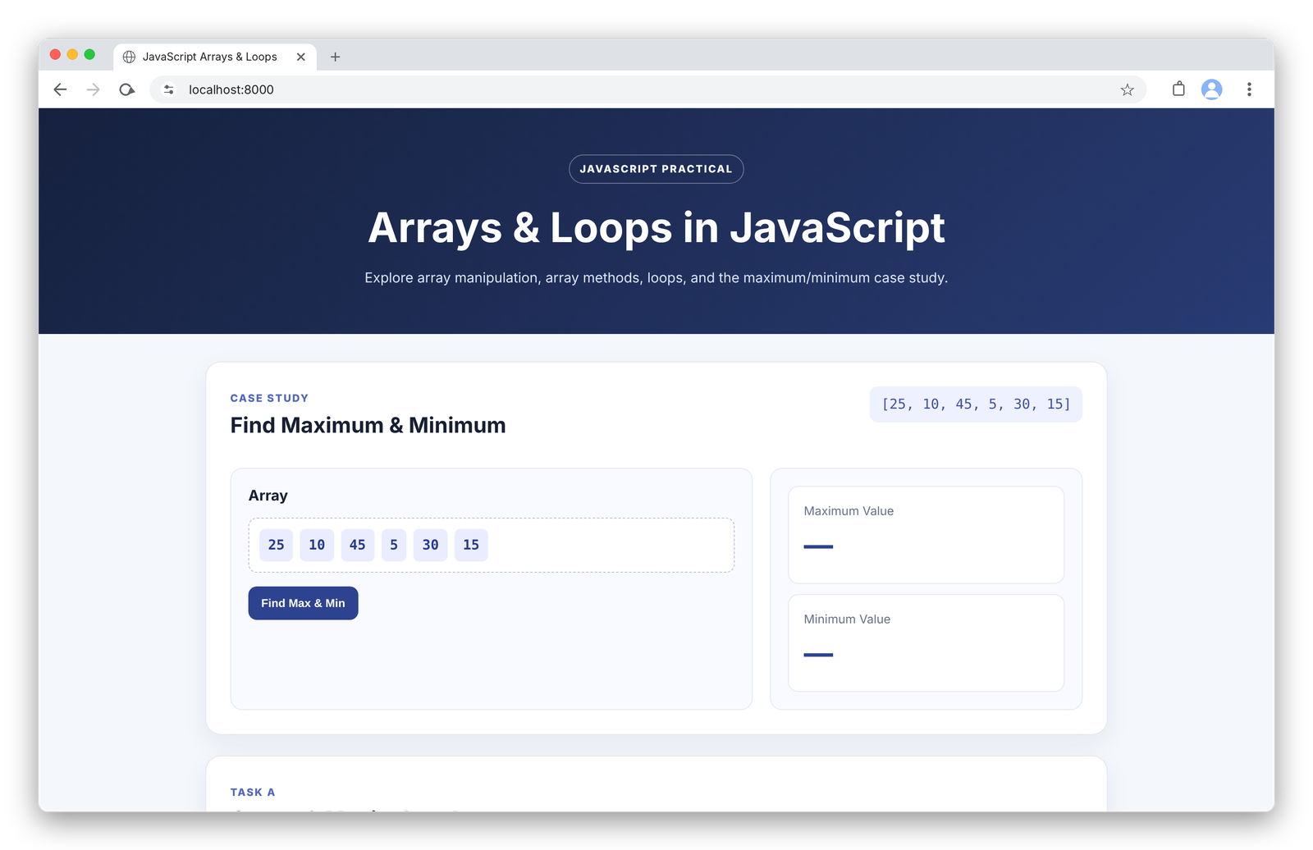
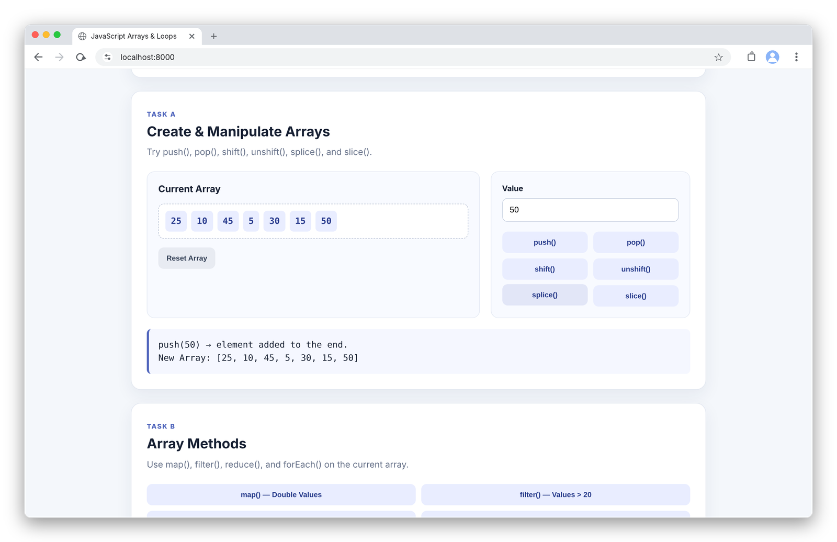

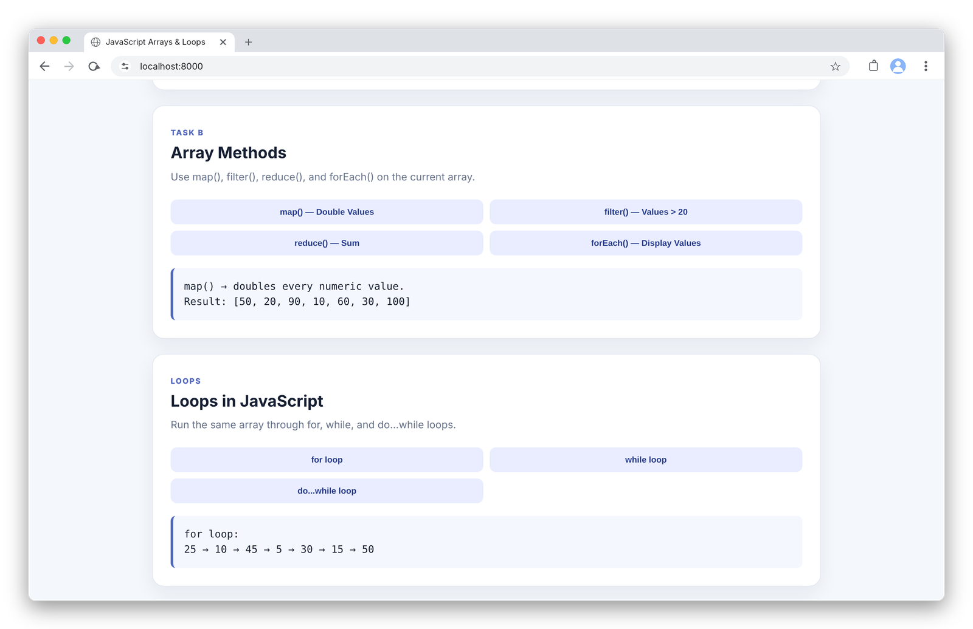
RESULT
The experiment was successfully performed and the concepts of JavaScript arrays, array methods, and loops were studied and implemented. The program successfully demonstrated array creation, manipulation, traversal, and data processing using various built-in functions and looping techniques.

